The Revelation Experience
____

QUSAYY & THE QURAYSH OF THE HOLLOW

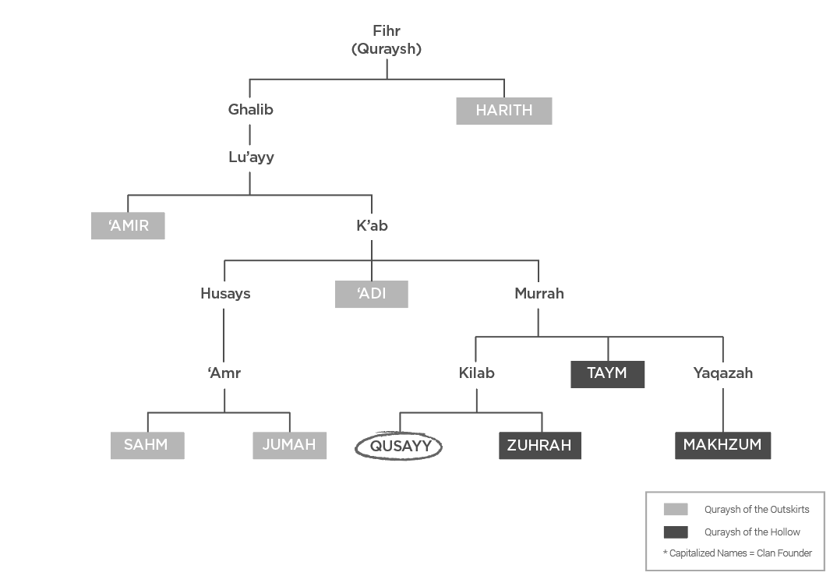

©Whiteboard Press, LLC. All rights reserved.
REVELATION: The Story of Muhammad (pbuh)
taken from

NOTES:

_______________________________________________________________________________________________________________________________________________________________________________________________________________________________________________________________________________________________________________________________________________________________________________________________________________________________________________________________________________________________________________________________________________________________________________________________________________________________________________________________________________________________________________________________________________________________________________________________________________________________________________________________________________________

